WELCOME TO PG DEPARTMENTS
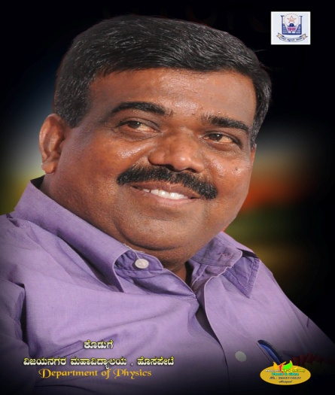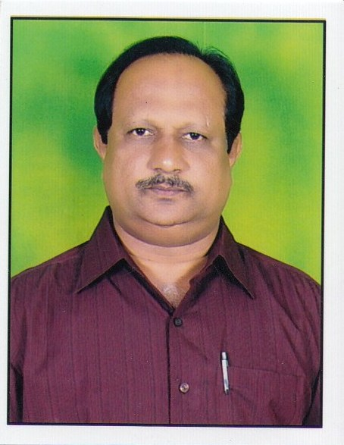
SRI GUTTIGANUR VIRUPAKSHA GOUDA DR.S.B.BELLAD PRINCIPAL
CHAIRMAN COLLEGE GOVERNING BODY
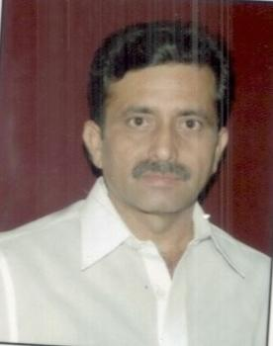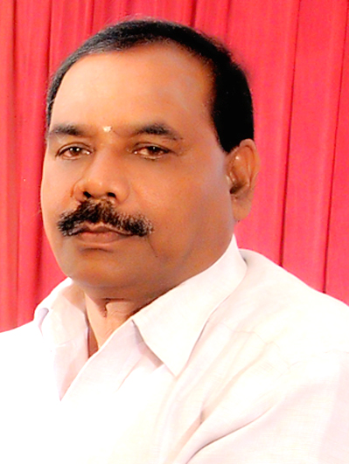
SRI SRINIVAS REDDY SRI BAPPAKANE KUMARASWAMI
MEMBER, COLLEGE GOVERNING BODY MEMBER COLLEGE GOVERNING BODY

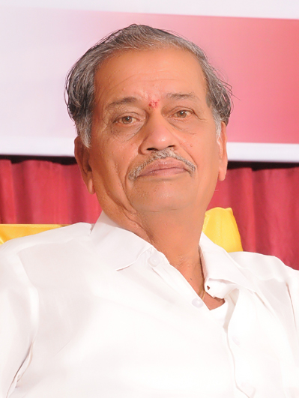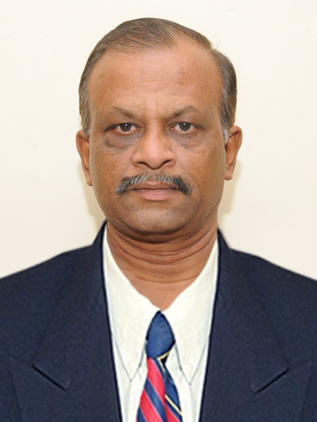
SRI SHANKAR GOUDA MEMBER SRI G SATISH MEMBER,
COLLEGE GOVERNING BODY COLLEGE GOVERNING BODY

Department Of Computer Science

The department of computer science was established in the year 1993 starting with B.Sc CS in the year 1993; the department was extended to M.Sc CS in the year 2001. The department had another feather to its cap when it opened BCA course in the year 2007. The primary goal of the department is to prepare well learned post graduates who can become excellent professionals.

Till date we have achieved 100% results. We have two well equipped laboratories. Campus placement takes place every year. In addition to the main library of the college, the department has a separate dedicated library for the department. Professional from the industries delivers guest lectures, so that the students come in touch with the industries. The department library has the internet facilities for the students for accessing educational material. All the staff are most experienced.

Eligibility for admission MSc Computer Science
A candidate with 50% in the aggregate at BCA, BSc CS, BSc Electronics, BSc Mathematics, BSc Information Science Or Information Technology, Bsc Statistics, PGDCS/PGDCA from recognized University, BTech/BE( any branch).

M.Sc Rank List:

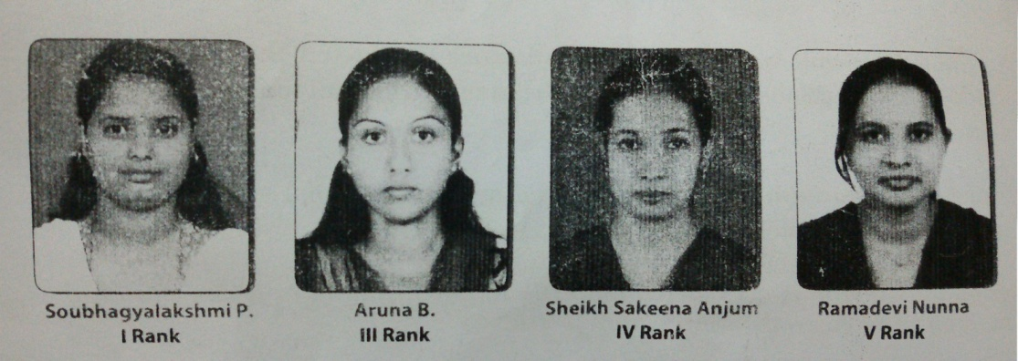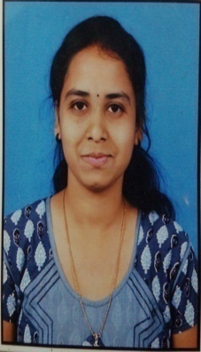
PROSPECTUS
The veerashaiva vidyavardhaka sangha, Bellary that was established in 1916 has been rendering yeomen service to the cause of education in this region. It is running more than 30 educational institutions right from primary school to post graduation, technical and professional colleges. To meet the educational needs of the people in and around Hospet, the sangha started vijayanagar college Arts, Science and commerce at Hospet in 1964. Starting with a humble strength of about 150 students, the college has trends in the education.
With its extreme sensitivity to national policies and community needs the college has grown strength to strength. The college now has 5000 students on its rolls. The college is affiliated to vijayanagar Sri Krisnadevaraya University, Bellary. The college is well equipped and is staffed with duty minded experienced teachers. The college has been getting ranks every year UG and PG examinations. The PG department of Computer Science was started in the year 2001 to bring our students on par with national standards. Later the PG department of Commerce, Physics, Chemistry, Economics and English joined the success path of the college.
The laboratories in physics, electronics, chemistry, Computer science, botony and zoology are well equipped and properly maintained. Various academic and literary activities are conducted through students Associations. These activities add up to make the campus a vibrant space for developing one’s personality. College Alumni form part of the national and international as elite scientists, intellectuals, administrators, corporate managers and leaders.

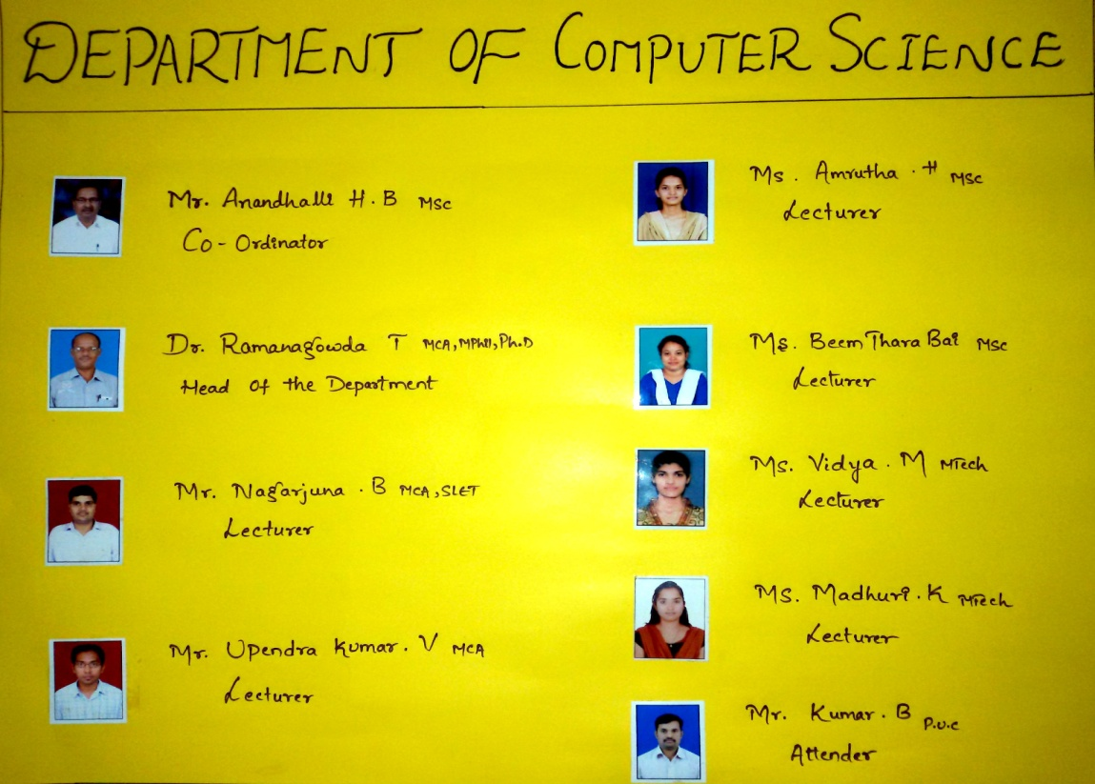

RANKS SECURED
SI.NO | NAME | COURSE | YEAR | RANK
1 | RAJESHWARI | MSc CS | 2011-12 | II
2 | AKSHATHA SHERKE | MSc CS | 2011-12 | IV
3 | SUSHMITHA PANDE | BCA | 2012-13 | III
4 | DHANALAKSHMI M | BCA | 2012-13 | X
5 | SARASWATHI | MSc CS | 2012-13 | I
6 | NAYANA M P M | MSc CS | 2012-13 | II
7 | REHANA BEGUM | MSc CS | 2012-13 | III
8 | ASHWINI VEDAPATHAK | MSc CS | 2012-13 | IV
9 | DEEPA | MSc CS | 2012-13 | V
10 | VIJAYALAKSHMI MUDDI | MSc CS | 2012-13 | V
11 | SOUBHAGYALAKSHMI P | MSc CS | 2013-14 | I
12 | ARUNA B | MSc CS | 2013-14 | III
13 | SHAIK SAKEENA | MSc CS | 2013-14 | IV
14 | RAMADEVI NUNNA | MSc CS | 2013-14 | V
15 | KUSHUBU | BCA | 2013-14 | III
16 | SHILPITHA | BSc CS | 2013-14 | V

NATIONAL LEVEL ROBOTICS COMPITATION, IIT DELHI

The National level robotics workshop has been conducted in PDIT College, Hosapete.
After qualifying in zonal level, our students participated in national level robotics compitatiion in IIT Delhi.
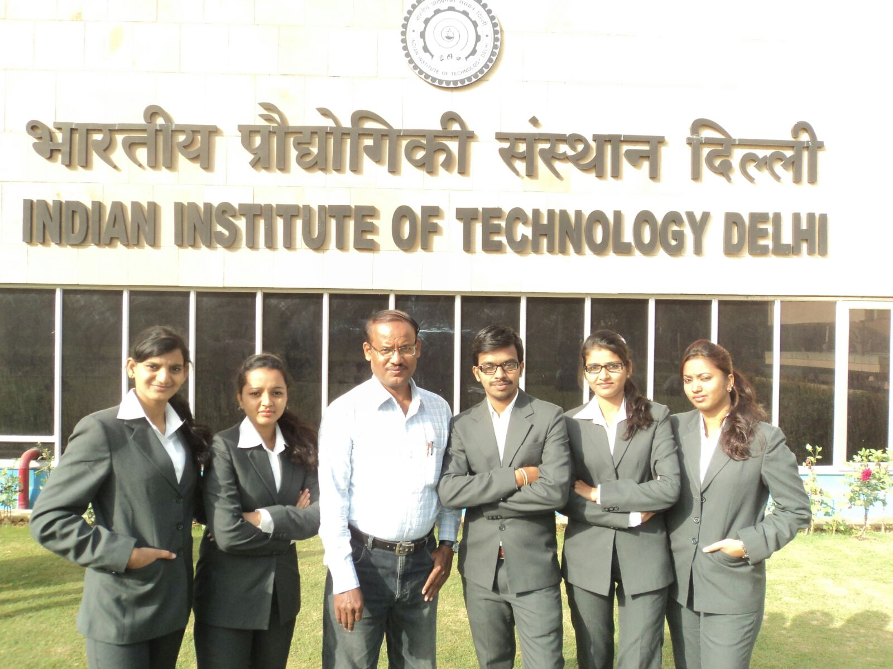
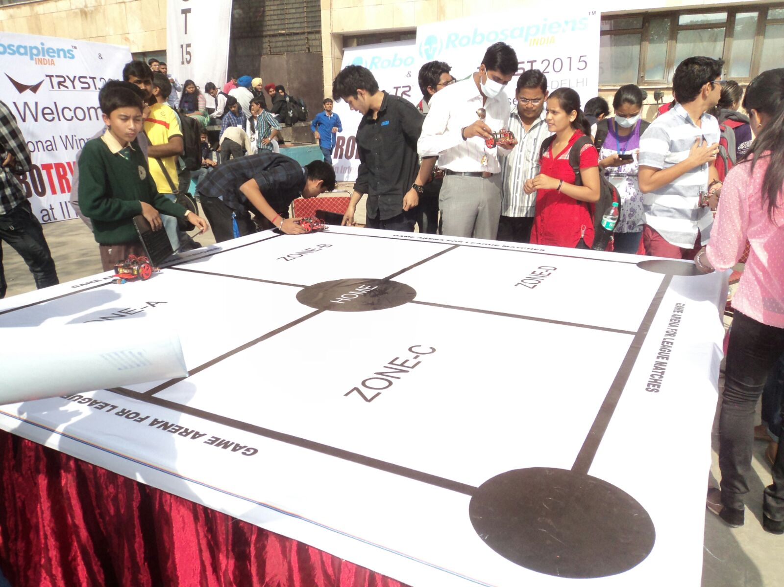

Class Room Teaching

Every year PG students were allowed for class room teaching. Students of MSc computer science will take class for degree students.

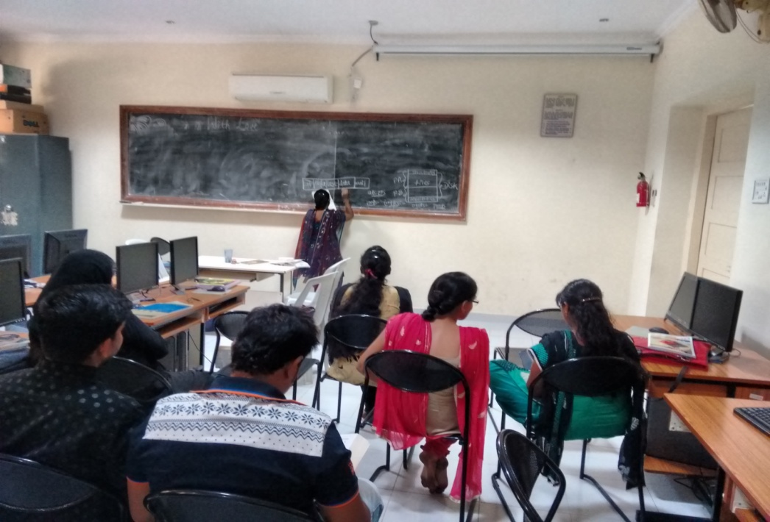
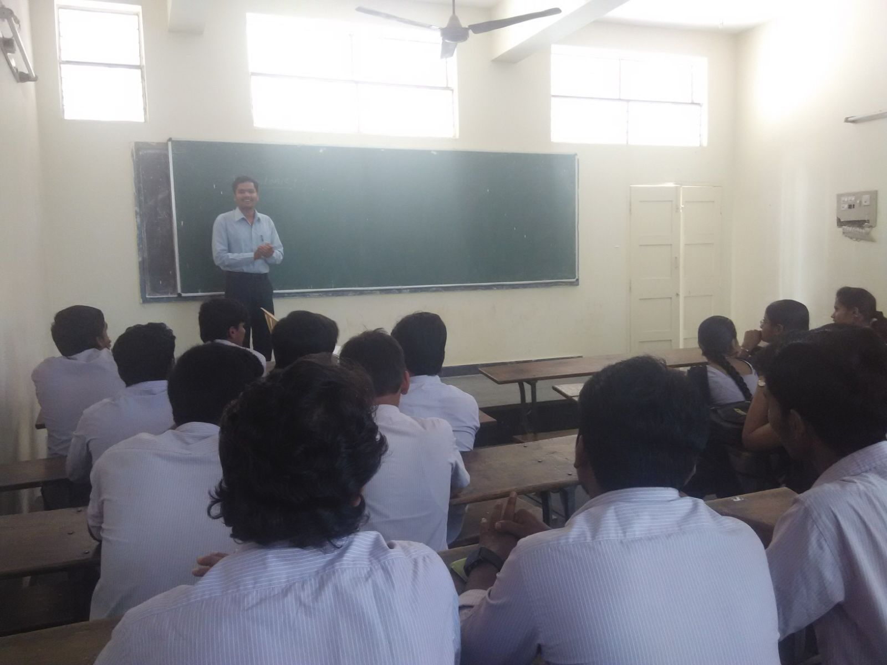
ROBOGO ’15 National Level Robotics Workshop
Theme: ROBOGO - National level robotics workshop
Date: 7-Sep-2015 and 8-sep-2015
Sessions: Session 1:- 7th Sep 2015 Time: - 9am to 5pm
Session 2:- 8th sep 2015 Time:- 9am to 6pm
Worshop Guide: Er.Aakash
Guests: Dr.S.S Police Patil (Principal VNC), Anadahalli H B (Co-ordinator CS)
Workshop Co-ordinators: Dr.Ramangowda T (HOD CS)
Asst.Prof Tanuja A
Asst.Prof Upendra Kumar
Hosts: Asst.Prof Nagarjun B
Asst.Prof Madhuri K
Asst.Prof Vidya M
Asst.Prof Amrutha H
Asst.Prof Thara B.

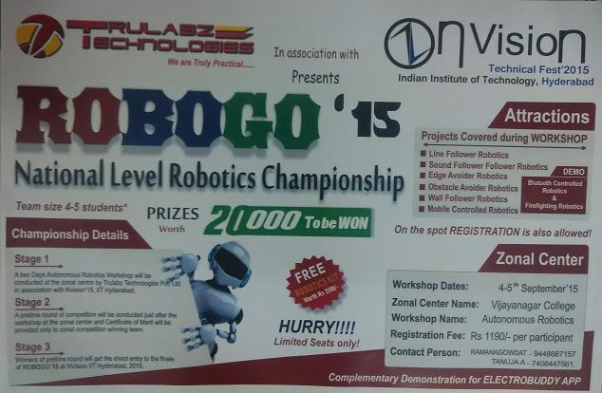

The National level ROBOGO Workshop was held on 7th and 8th Sep 2015. Inguaration started at 8am, the guests were welcomed by HOD of CS Department DR.Ramangowda T. The Guests included Principal of VNC Dr.S.S Police Patil and Co-ordinator of CS dept Anadahalli H B and the workshop guide Er.Aakash spoke about his workshop and inspired all the students to actively participate in the workshop.
Projects Covered during Workshop are listed below
- Line Follower Robotics.
- Sound follwer Robotics.
- Edge avoider Robotics.
- Obstracle Avoider Robotis.
- Wall Follower Robotics.
- Mobile Controlled Robotics.

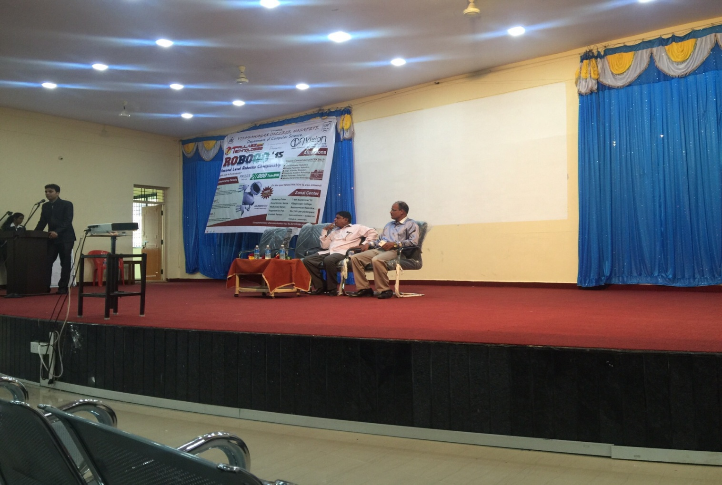

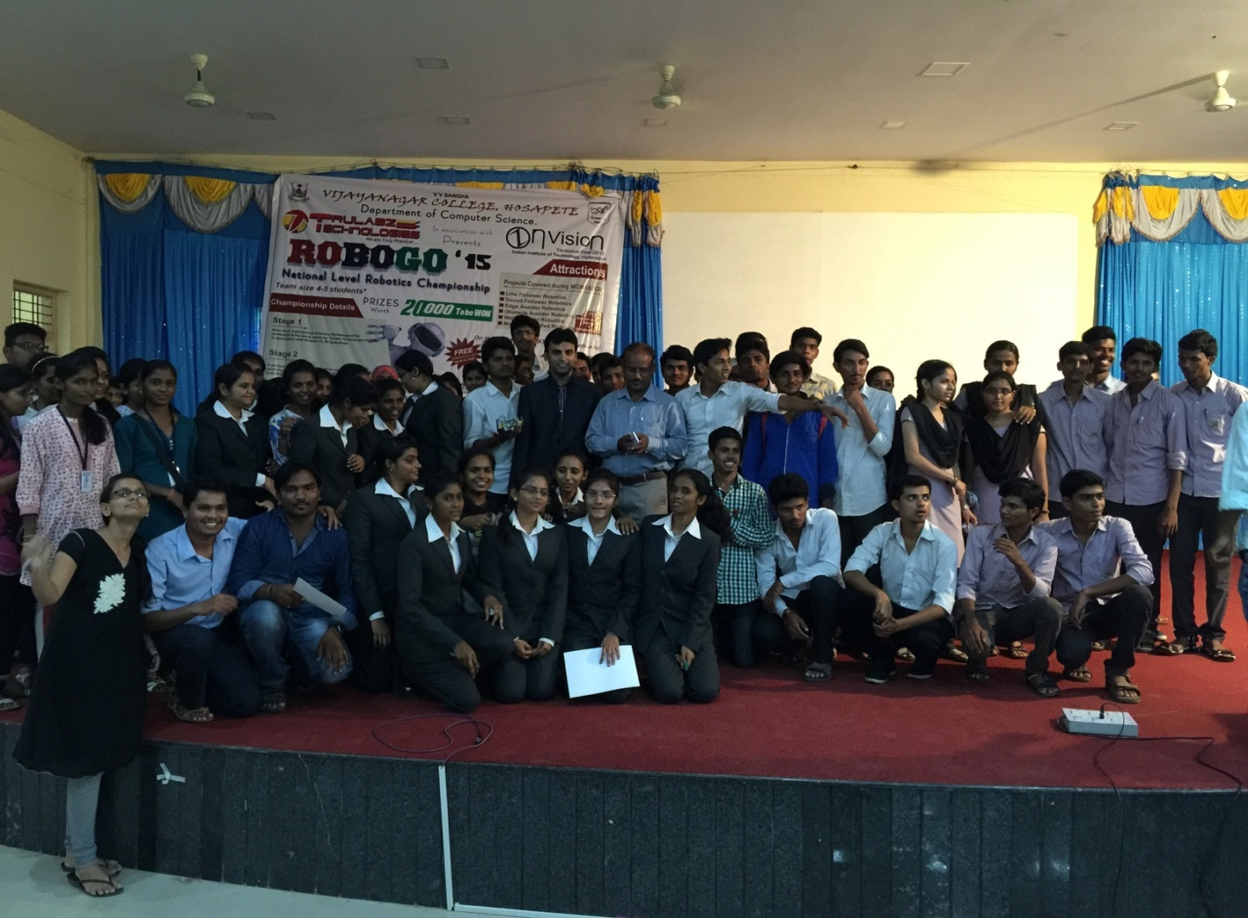

COMPUTER SCIENCE

Friday Events:

Every Friday from CS department technical seminars will be conducted along with that aptitude training. On every last Friday of the month an events such as aptitude tests will be conducted in the conference hall.

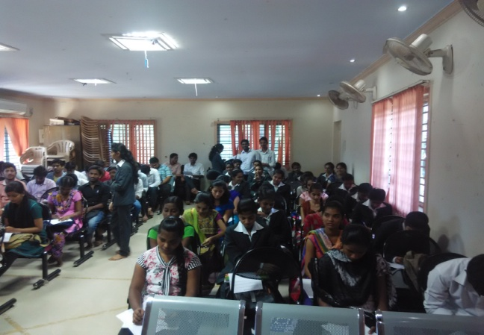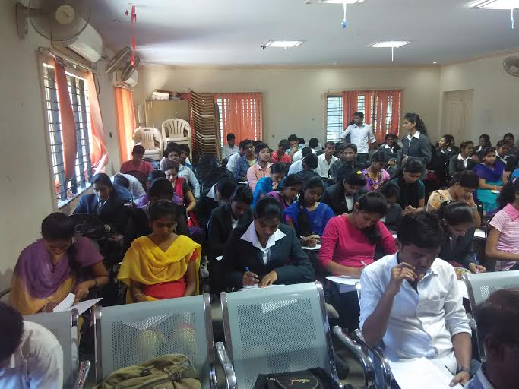

Participated in the fest JSS Dharwad.
Our students participated and won prize in the various events conducted in JSS College, Dharwad 2012-13

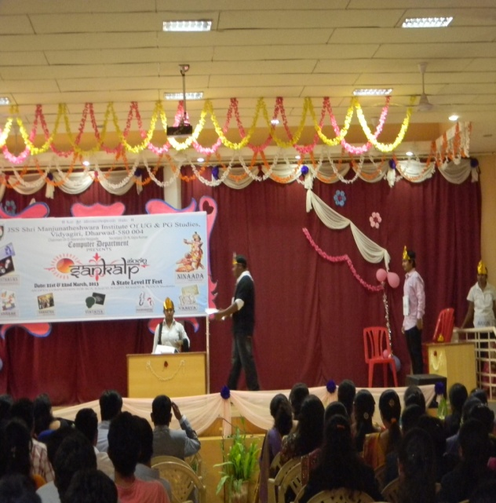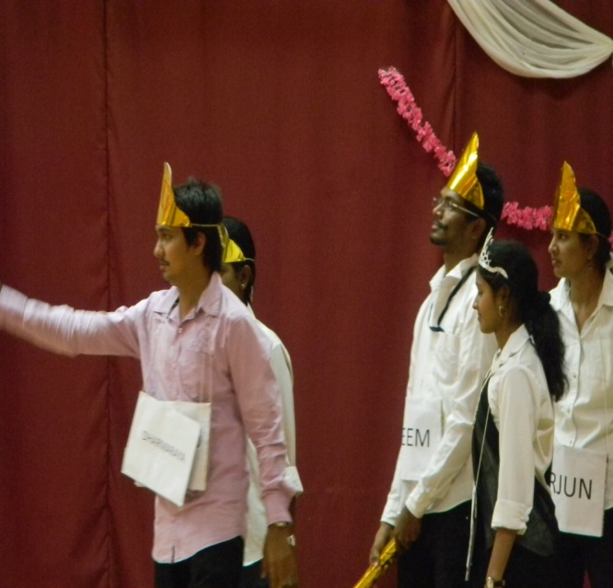

AAPRA2 Inter College State Level IT Fest
In 2014-2015 Students from Various places such as Ballari, Koppal, Sirgupa, Dharwad, Belgam, etc. participated in the inter college state level IT fest in VNC Hosapete.
The events such as
- Photography
- Coding
- Treasure hunt
- Ice breaking

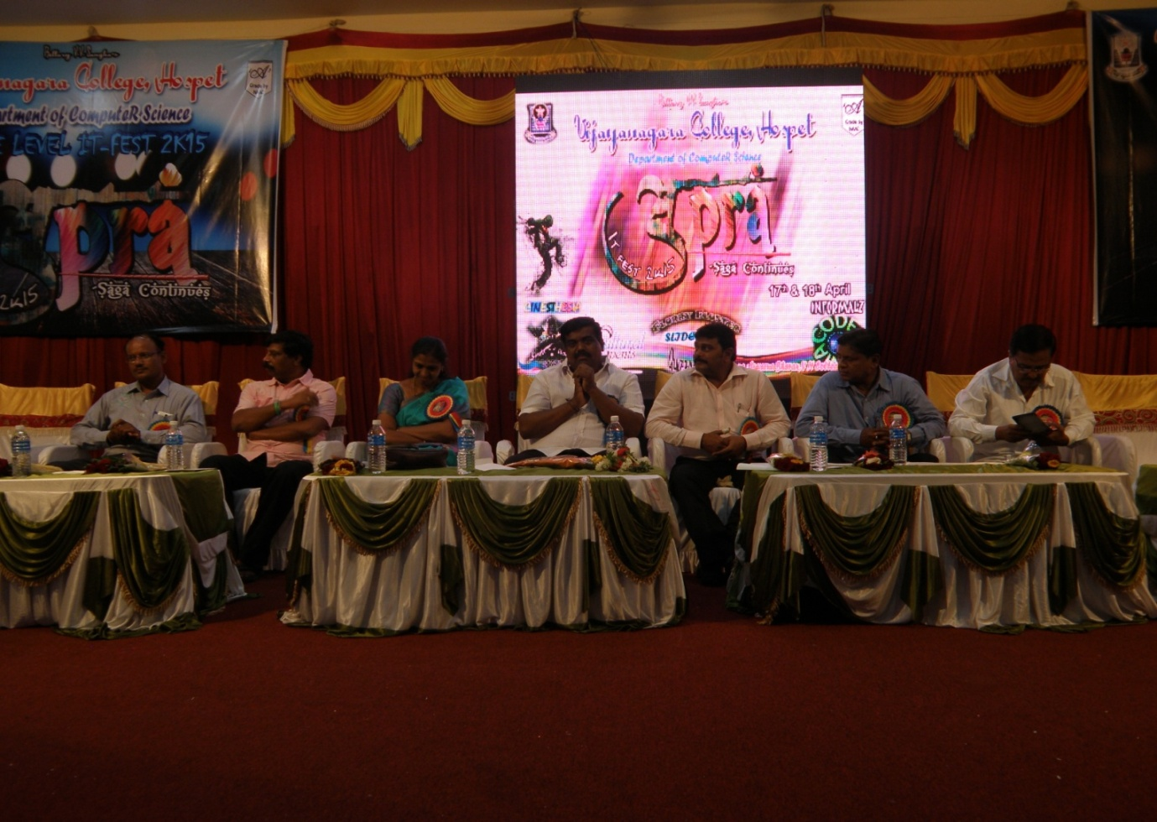
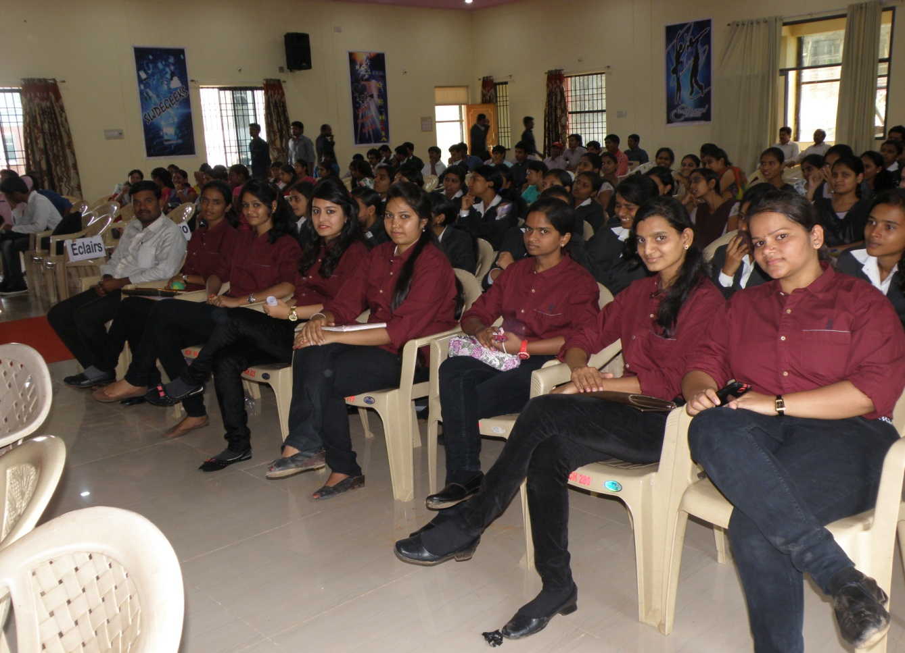

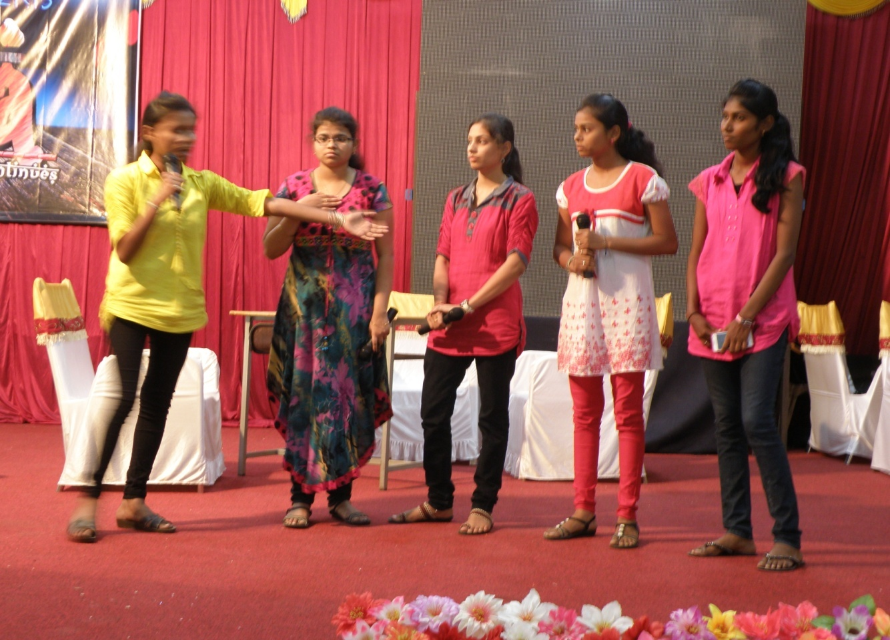

Teachers day Celebration

Every year teacher’s day will celebrate in Department .The day marks as a day of gratitude and respect to the selfless efforts of teachers. This day is also celebrated to honor Dr. Sarvepalli Radhakrishnan, the great teacher, academic philosopher and India's Second President as he was born on the same day in 1888. Dr. Radhakrishnan was a strong supporter of education. Instead of celebrating his birthday separately he requested to observe the day as Teachers' Day to give honor to all the teachers in India. This appeal demonstrated his love for the teaching profession and since then 5th September is celebrated as Teachers' Day in India. Most students offer gifts like greeting cards, flowers, pens, books.

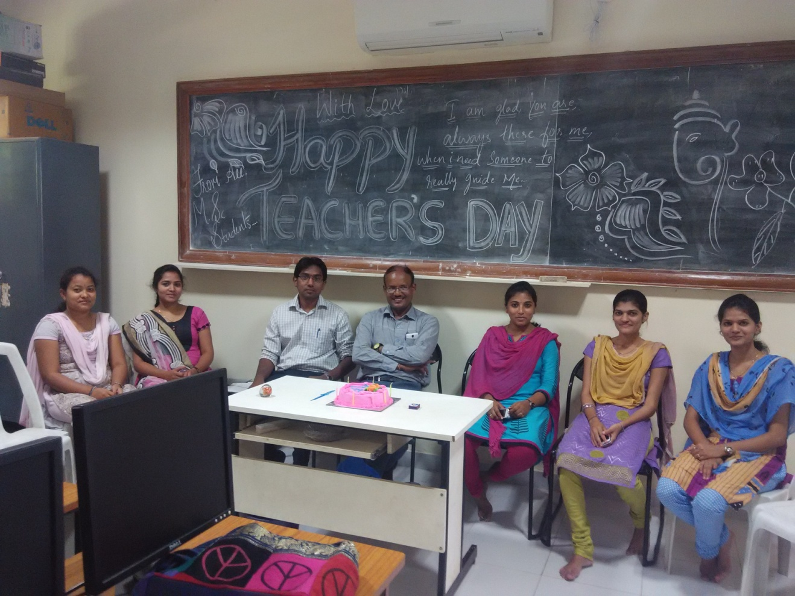

Department of M.Com (Master of Commerce)
The Department of commerce was established in Vijayanagara College Hospet in the year 1964. The Department of commerce and management of this college is running B.com General, B.com Vocational (CS), BBM and M.com Courses. There are more than 1300 B.com General, Students and more than 120 students in B. Com Vocational, more than 180 students in BBM. Master of Commerce (M.com) was introduced in the year 2010 with the strength of 25 but strength has been increased to 100 till date.
The department has good infrastructure and highly qualified, experienced and dedicated staff. Separate computer laboratory with internet facility is also provided to all the students. Department library has good number of latest books, journals, magazines, management learning CDs etc.
There is a separate tutor to undertake soft skill programs like spoken English, PDP etc. All PG classrooms have smart boards and classes will run through PowerPoint. Individual care for student is our top priority. The department has secured 100% result with many first classes, distinctions and ranks. A sound placement cell in the campus provides a career boost to the students.
Eligibility for M.com Course (M.com)
The candidate with minimum 50% marks in aggregate at B.com, BCS degree from recognized university.
Duration of the course: A course study is of two years. Each year consisting of two semesters. The course study will be consisting of 20 Subjects and spread over 4 Semesters.

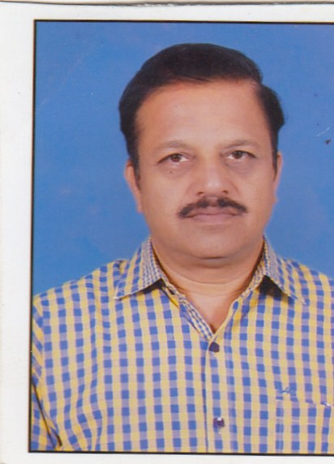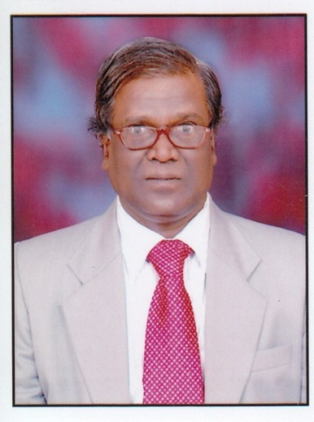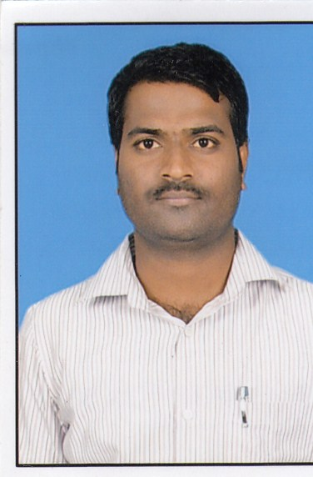
Dr.K M Manjunath Dr.M J Basavaraj Dr.Murugesh T M
HOD.

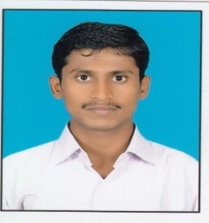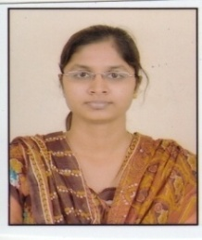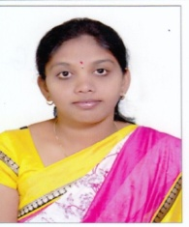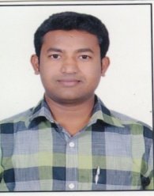
Sri Kotresh VB Miss G Arpitha Miss A G sunitha Sri.Ravikumar

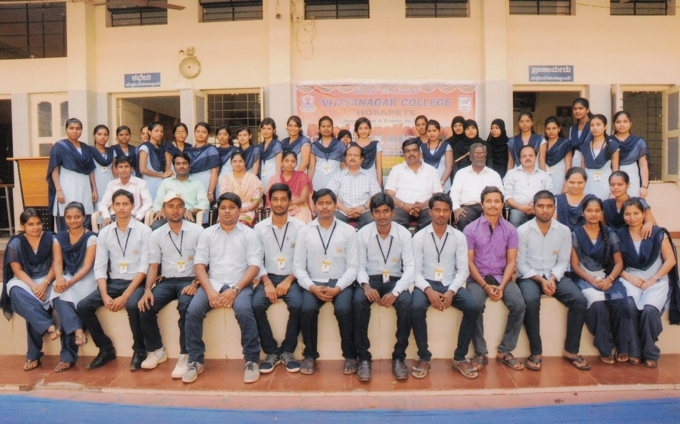

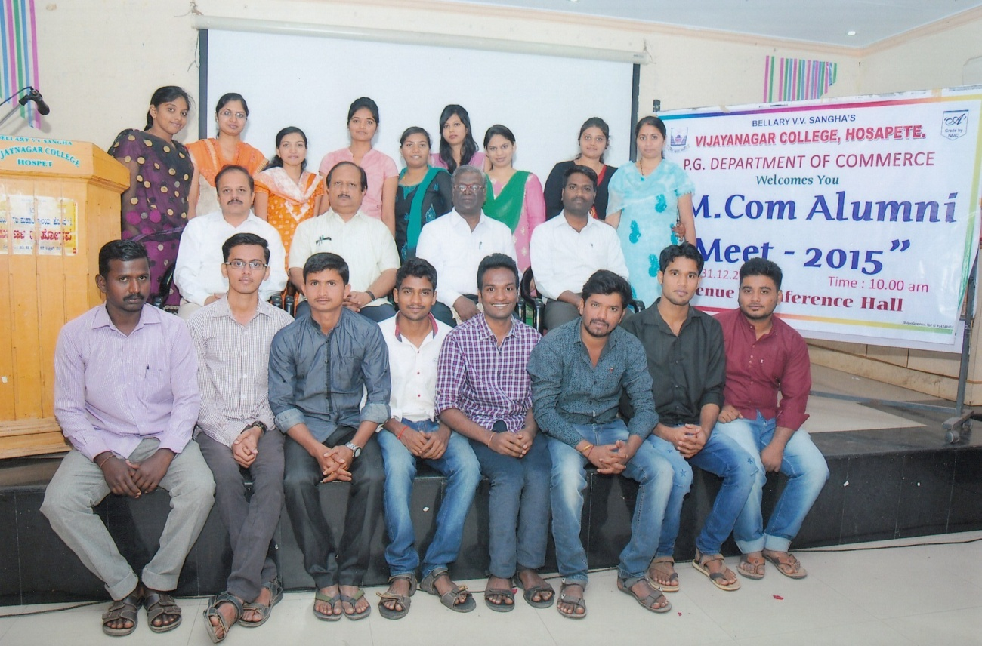

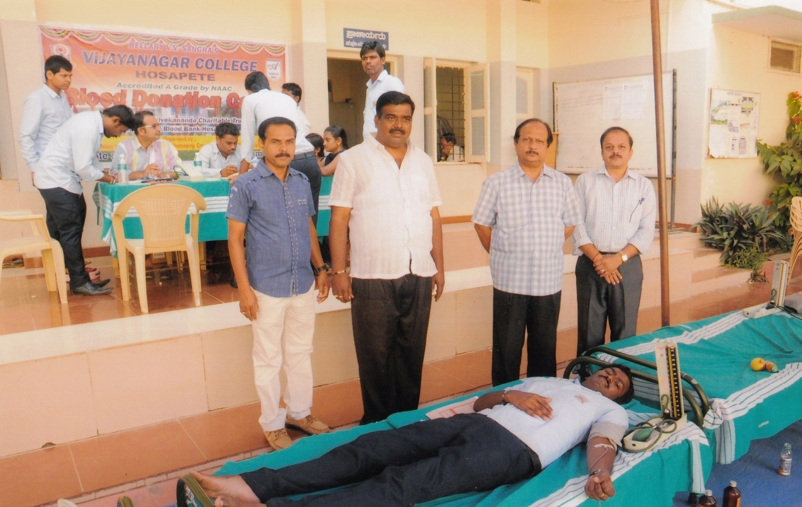

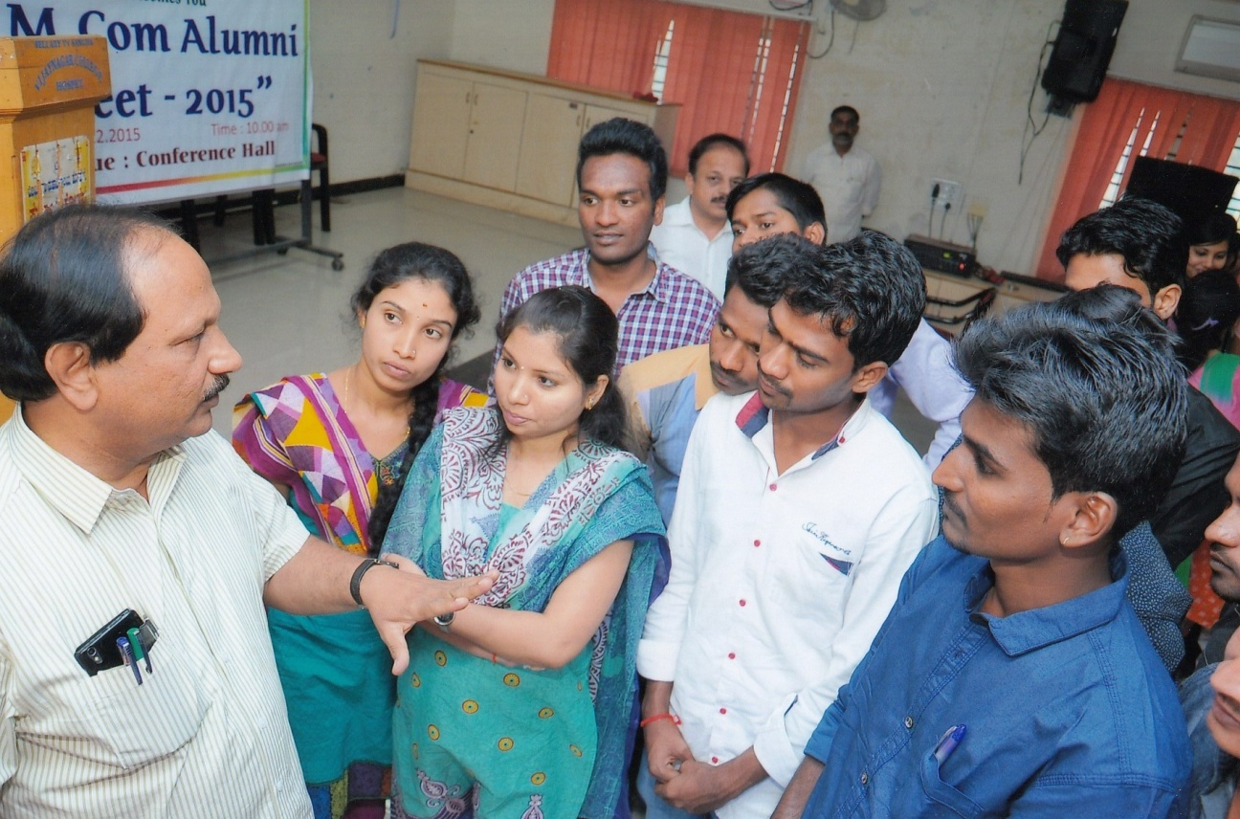

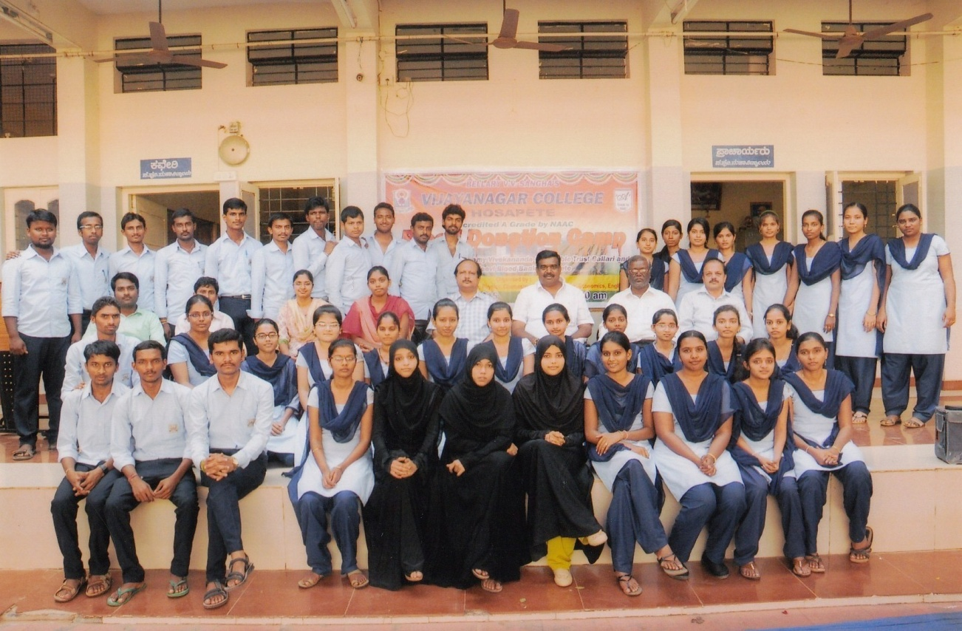

Bellary V V Sangha’s
VIJAYANAGAR COLLEGE, HOSAPETE
DEPARTMENT OF PG STUDIES AND RESEARCH IN PHYSICS
The PG department of Physics was introduced in the year 2011 with a primary goal to prepare well – learned post graduates. From its inception the department has grown as one of the largest departments in the campus. The department offers “ Solid State Physics “ as the specialization. Well equipped laboratory and classrooms ease the conceptual problems faced by the students.
The outstanding performance of the department is evident from the fact that it has been scoring 100% results in the final year examinations of the course over the last three years. The Department bags university ranks every year.Due to its comprehensive facilities and reputation , the college department today attracts students from our and other institutions .
In the atmosphere of mutual trust and understanding the faculty is committed to create a climate of excellence that is marked by the academic performance of the students.Highly qualified and experienced staff members continuously work on research programmes and are capable of guiding the students to reach their goal. Students undertake projects under the supervision of the senior faculty.
The post graduates in physics from our college are placed in various institutions.Frequent academic activities like seminars , special guest lectures, workshops, individual talent show make the students competent to face the future challenges. Individual care, personality development and career boost for the students is the top priority of the department.
The department of physics in our college is well equipped with three independent laboratories (Electronics lab, General Physics Lab and Dark room ). We have experimental apparatus like Zeeman effect , Hall effect, Gouy’s method,Quincke’s method,Ultrasonic Interferometers,Lasers, optical Bench , Electronic apparatus – CROs,Signal generators with Power supplies. The department is also inviting the learned guest faculty from universities and research institution for the benefit of PG students in Physics. Around 10 research publications are there to the credit of faculty members of the department. Research projects are continuously undertaken by the faculty members.
- Year wise admission of students to M.Sc Physics course and Result

Year | Class Admitted | Total Admitted | Male | Female | Result (%)
2011-12 | M.Sc I Sem | 18 | 09 | 09 | 100
2012-13 | M.Sc I Sem | 33 | 10 | 23 | 99
2013-14 | M.Sc I Sem | 30 | 08 | 22 | 100
2014-15 | M.Sc I Sem | 24 | 04 | 20 | 99
2015-16 | M.Sc I Sem | 21 | 06 | 15 | Result awaited

- Conferences /Seminars/lecture series attended by Post Graduation(Physics) Staff and Students (From 2012 to Present)

- Academy Conference: “Science and Society” organized by KSTA in association with Veerashaiva College, Ballari during 16 and 17th January, 2015.
- State Level Seminar: Glimpses of Nanoscience and Nanotechnology organized by Department of Physics, Vijayanagar College, Hosapete on 16 and 17th March, 2015.
- One Day Lecture Series in Smart materials organized by PG Department of Physics, Vijayanagar College, Hosapete on 14th October, 2015.
- One day state level seminar on alternate energy sources organized by Department of Physics, G.B.R College, Huvina Hadagali on 10th October, 2015.

- Faculty profile

Name | Qualification | Designation | Experience  (Years) | Specialization
PERMANENT STAFF
Dr. S B Bellad | M.Sc.,Ph.D | Principal | 30 | Applied Electronics
Dr. U J Pattar | M.Sc., Ph.D | Associate Professor | 28 | Applied Electronics
Prof H B Anandhalli | M.Sc, M.Phil | Associate Professor | 28 | Nuclear Physics
Dr. M Prabhugouda | M.Sc.,Ph.D | Associate Professor | 25 | Nuclear & Energy Physics
Prof. Basanna Digge | M.Sc., M.Phil | Associate Professor | 25 | Nuclear & Energy Physics
TEMPORARY STAFF

Kum. Shereen Taj P | M.Sc. | Assistant Professor | 01 | Solid State Physics
Kum. Aasha K S | M.Sc. | Assistant Professor | 01 | Solid State Physics

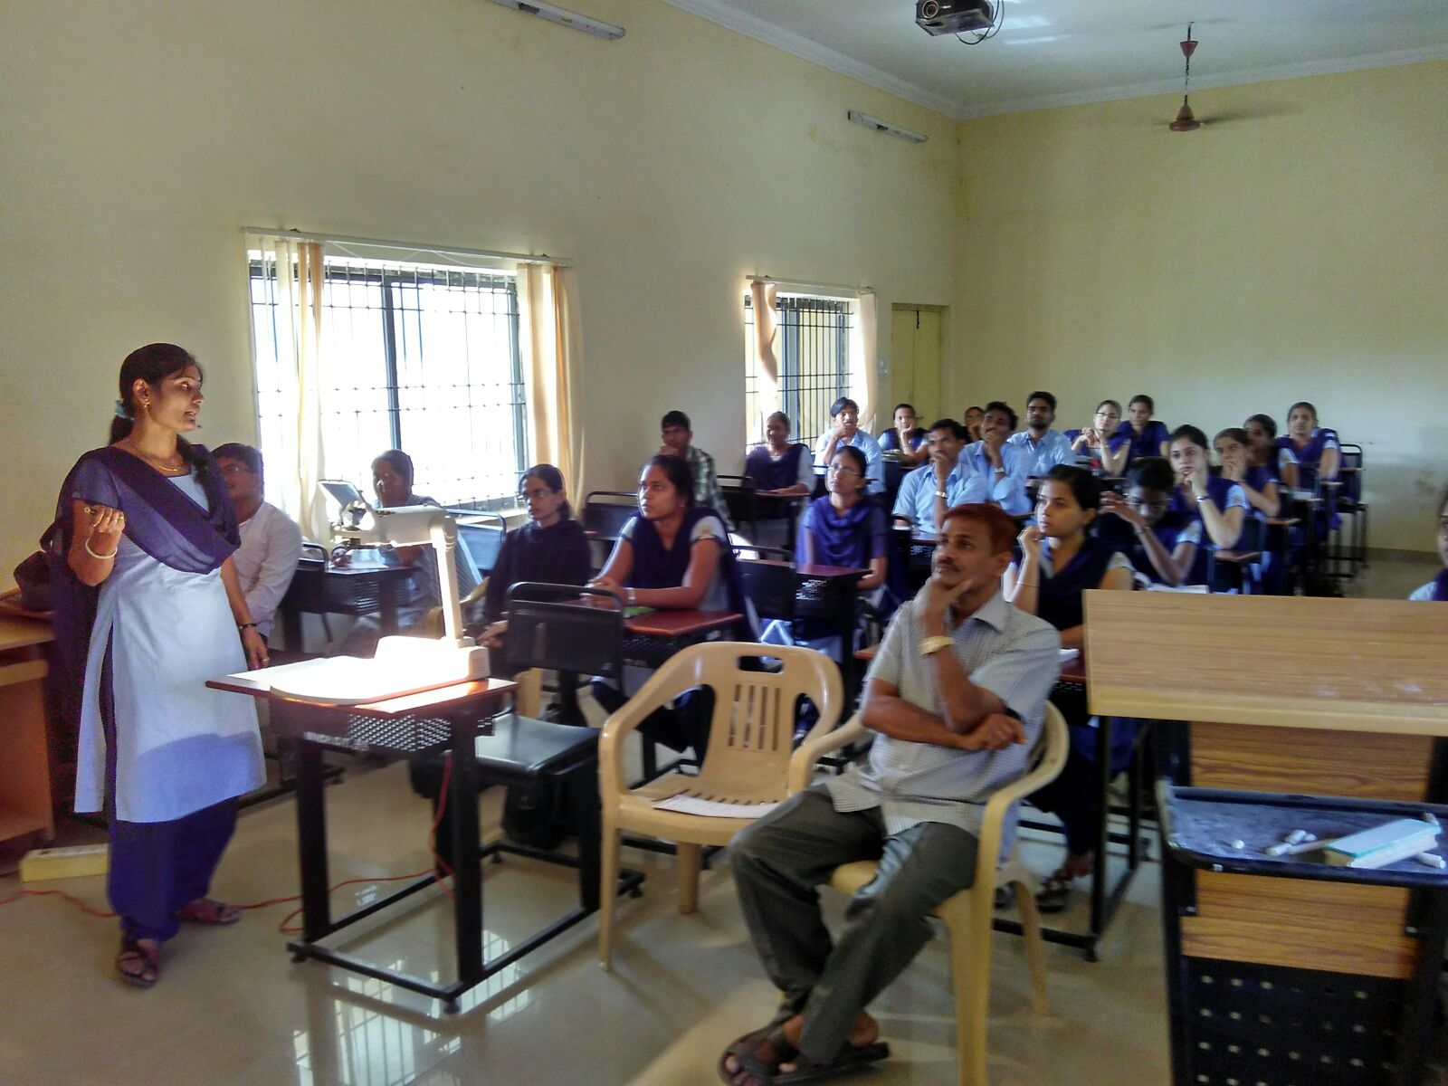

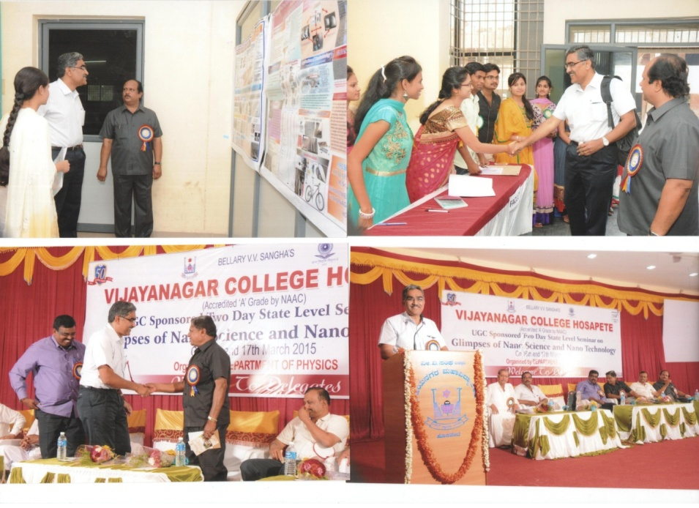

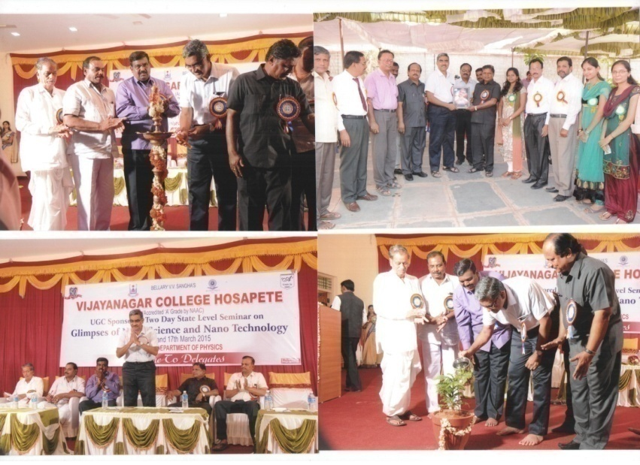

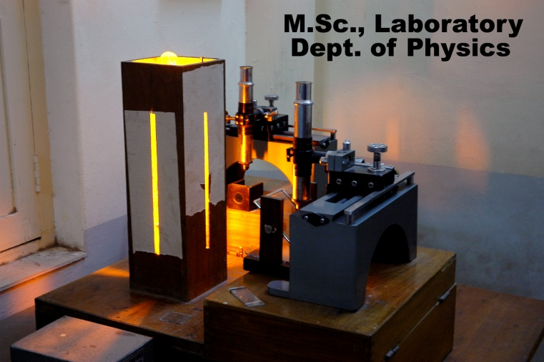

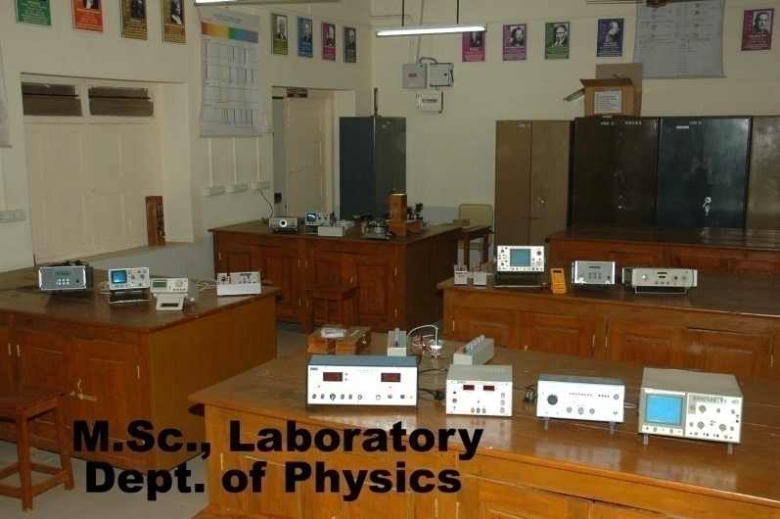

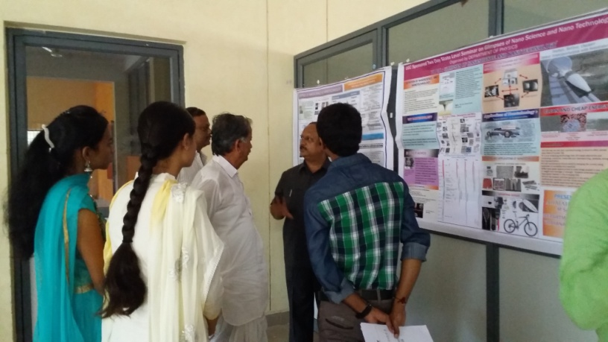

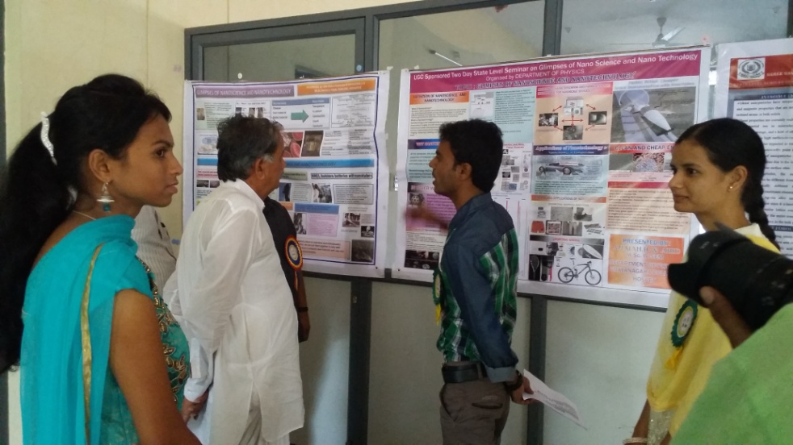

Bellary V V Sangha’s
VIJAYANAGAR COLLEGE, HOSAPETE
DEPARTMENT OF PG STUDIES AND RESEARCH IN CHEMISTRY

The department of chemistry in our college is well equipped with five independent laboratories (semi-micro, organic, physical inorganic and PG Lab). We have analytical grade chemicals, sophisticated instruments such as Flame Photometer, UV-visible spectrophotometer, Muffle furnace, Potentiometer, conductrometer etc.
The faculty of the department has more than 10 years teaching experience for PG chemistry and exposure to UGC Minor Research Projects. The department is also inviting the learned guest faculty for the benefit of PG students in chemistry from universities and research institution. Around 25 research publications are there to the credit of faculty members of the department. Research projects are continuously undertaken by the faculty members
During course studies post graduation students have carried out their M.Sc projects in collaboration with different laboratories, colleges and universities such as Soniya Educational Trust of M. Pharmacy College, Dharwar, University of Agricultural Sciences, Dharwar. During their course studies, students have attended different Conferences, Seminars, lecture series and interacted with eminent Scientist, Professors and Resource persons from various places. One of our M.Sc Chemistry student Miss. Gayathri has secured fifth rank from Vijayanagar Sri Krishnadevaraya University, Ballari during year 2013-14 and we expecting ranks this year also. Overall the PG department of chemistry is dedicating itself to the all-round development of students.
- Year wise admission of students to M.Sc Chemistry course and Result

Year | Class Admitted | Total Admitted | Male | Female | Result (%)
2012-13 | M.Sc I Sem | 18 | 12 | 06 | ___
2013-14 | M.Sc I Sem | 18 | 10 | 08 | 94
2014-15 | M.Sc I Sem | 14 | 9 | 05 | 100
2015-16 | M.Sc I Sem | 17 | 11 | 06 | Result awaited

- Conferences /Seminars/lecture series attended by Post Graduation(Chemistry) Staff and Students (From 2012 to Present)

- Post Graduate Science special lecture series organized by V.S.K. University, Ballari held at Alum Karibasappa Institute of Management, Ballari during 8 and 9th November, 2013.
- Academy Conference: “Science and Society” organized by KSTA in association with Veerashaiva College, Ballari during 16 and 17th January, 2015.
- State Level Seminar: Glimpses of Nanoscience and Nanotechnology organized by Department of Physics, Vijayanagar College, Hosapete on 16 and 17th March, 2015.
- One Day Lecture Series in Advanced Chemistry organized by Department of Chemistry, Vijayanagar College, Hosapete on 4th April, 2015.
- Nature Architechture of Chemistry organized by Department of Chemistry, Vijayanagar College, Hosapete on 19th October, 2015.

- Faculty profile
Name | Qualification | Designation | Experience  (Years) | Specialization
PERMANENT STAFF
Dr. Ashok Ullagaddi | M.Sc.,Ph.D | Co-ordinator and Associate Professor, | 30 | Organic Chemistry
Sri. K. S. Kottureshawra  Goud | M.Sc | Associate Professor | 25 | Physical Chemistry
Dr. B. Govindraj | M.Sc. B.Ed,  M.Phil,,Ph.D | Associate Professor | 25 | Physical Chemistry
Sri.B.P.Chandrashekarappa | M.Sc.,B.Ed | Associate Professor | 23 | Organic Chemistry
Dr. T. Basavaraj | M.Sc.,Ph.D | Associate Professor | 23 | Physical Chemistry
TEMPORARY STAFF

Dr. Jeelan Basha | M.Sc.,Ph.D | Assistant Professor | 04 | Organic Chemistry
Sri. GVK. Pavan Kumar | M.Sc.,B.Ed | Assistant Professor | 07 | Industrial Chemistry
Kum. Nabila Anjum | M.Sc.,B.Ed | Assistant Professor | 01 | General Chemistry

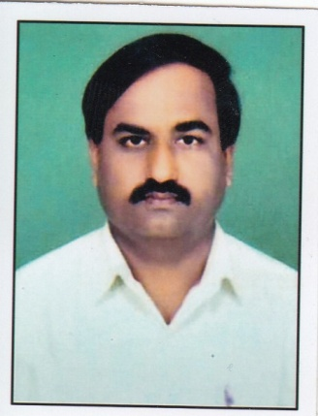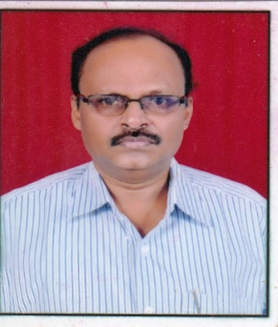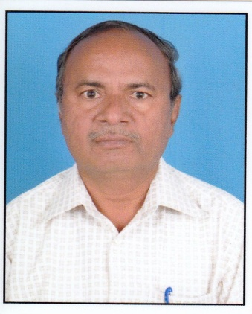
Dr.Ashok Ullagaddi Prof.Kotreshwara Gouda Prof.B P Chandrshekar

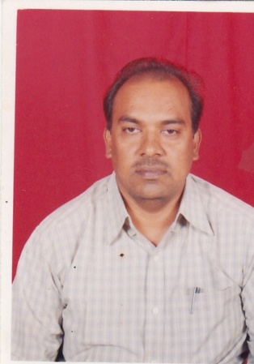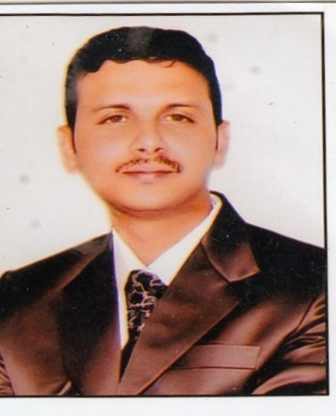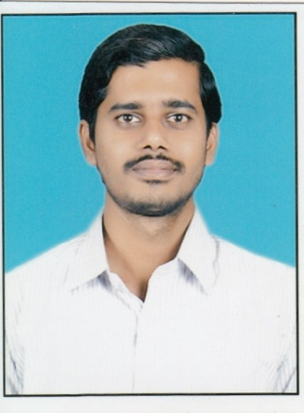
Dr.T.Basavarj

VIJAYNAGAR COLLEGE, HOSPET
PG Department of English
Since its inception the English language is a part of and parcel of our college .In fact our college privides a platform for experts of many languages, i.e., for languages like, Telugu, Tamil, Hindi, Kannda,& Urdu along with English. We privide an additional Opportunity for students to specialize in Additional English & Optional English along with Basic English. We started these specialized tracks wayback in 1980’s & in 1990’s.We offer these courses along with relevant on-the-job the training. Naturally these candidates successfully got opportunities at various high schools to teach English language. The strength of the department is growing in leaps and bounds over the years.
Of late, there is a growing demand from the society at large to give a fillip to UG English education. Hence, we started PG in English from 2013-2014 onwards. No doubt M.A. English is a “Professional Track”. In keeping with the related trends, we’ve established a language lab to hone their language skills.
All the courses are naturally supported by well established and separate UG/PG libraries. These are more than 1600 English books along with subscription to as many national and international magazines. Naturally, we’ve a well experienced faculty to support the entire education system.
Eligibility: As per the guidelines of Vijayanagar Sri Krishnadevaraya University, Bellary.
Details of the Course: Four semesters
Extra Curricular Activities: We regularly conduct seminars and group discussions at class room level. In addition to that, we conduct “Special Lecture Series”. For this we have decided to invite great and well-known scholars in ‘English literatures’. The Scholars range from various reputed Universities India/Abroad writers and senior faculty from Degree College’s etc.We established society to celebrate “Literature”i.e.Global English Literature Festival (GELF).Under GELF, We’Ve decided to conduct “Special Lecture seminar”.
On 13.October.2015, Under GELF, We have invited Prof.Shanta Naik,Head of English,VSKU Bellery.He delivered a highly creative lecture on “EUROPEAN” and “AFRICAN ENGLISH LITERATURES” In the “INTERACTION SESSION” the students got their doubts cleared from the lectures
On 09.Nov.2015, we invited Prof.Basavaraja Dept.of English GF College, Hospet to deliver a focused lecture on “INDIAN ENGLISH LITERATURE”. He focused on RK NARAIN.Later, as usual the “INTERACTION SESSION” followed to the intellectual satisfaction of all.
As the University has announced the I/II Sem PG exams from 04.DEC.2015 onwards, We’ve decided to put an end to the “Special Lecture Seminar” for this term. We decided to that them in the II and IV semester, i.e.from January 2016 onwards.
Prof. Aravind Nadahalli one of the senior faculties has retired in the year 2015, and the management has filled the vacancy with the guest faculty.

Faculty:
1. Dr.G.Umaheswar
2. Dr.Usha Rani Sharma
3. Prof.Niranjan
4. Prof.Shabbir
5. Prof.Jitendra

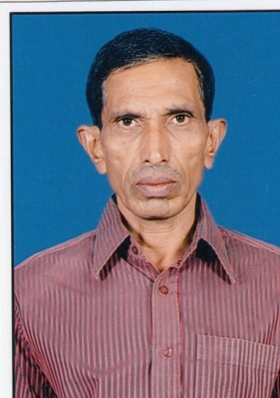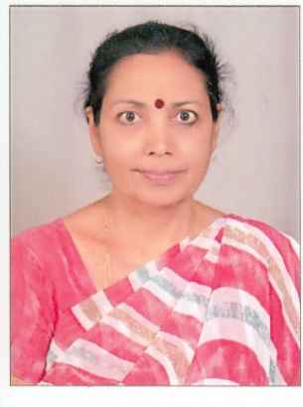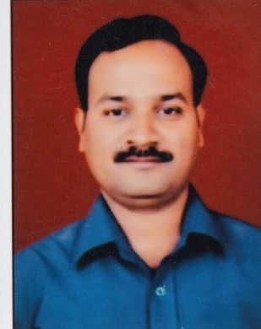
Dr.G.Umaheswar Dr.Usha Rani Sharma Prof.Niranjan

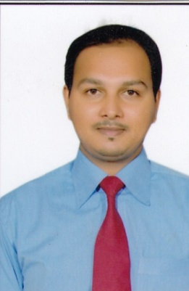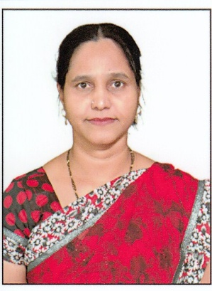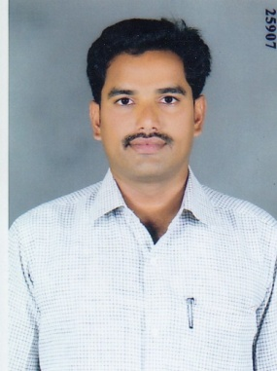
Prof.Shabbir Prof.Mubina Prof.Jitendra

Vijayanagara College, Hosapete.
PG Department of Economics.
The Veeerasaiva Vidyavardhaka Sangha, Bellary has established Vijayanagara College at Hospet way back in 1964. Since then it has become an ideal educational institution in north Karnataka. It has involved itself in providing quality education to all the sections of the society of the region. It has opened all the main streams, i.e. Arts, Science and Commerce to the students.
The college has started teaching ‘Economics’ since its inception only. Principals like Prof. Chandrashekarappa and Dr. H Basanna and other played a major role in promoting ‘Economics’ on priority basis. Since the beginning, the department has been exploring new ways to harness greater knowledge about ‘Economics’ along with the class room teaching. The result is the conduction of workshops, Seminars, Special lecture programmes , debates, group discussions and elocutions at regular intervals to get them best educational outcome, we conducted a National Seminar on ‘Special Economic Zones - An Indian Perspective’ in the year 2009. More than 350 delegates participated in that multidimensional seminar. Again in 2015, we organized a National seminar on ‘Foreign Direct Investment – In India’s Retail Sector Prospects and Challenges’. More than 275 potential delegates participated in that seminar. The department has also organized special functions on ‘Economics’ related issues for the students to upgrade their contemporary knowledge in Economics. For every academic year, more than 1500 students opt for ‘Economics’ in BA and B.Com courses.
‘Economics’ is one of the progressive subjects in social sciences. Keeping all these useful and interesting details in mind, we have started MA in Economics from 2014-2015. Our department is equipped with highly experienced and qualified. The well equipped library serves as a jewel in the crown.
FACULTY:-
Dr. S Y Thimmareddy, Co-Ordinator P.G. Department of Economics.
Dr. K Revanasiddappa
Prof. V B Veerappa
Mr. Suneel N
Smt. M S Mubeena
Mr. Anjaneya H

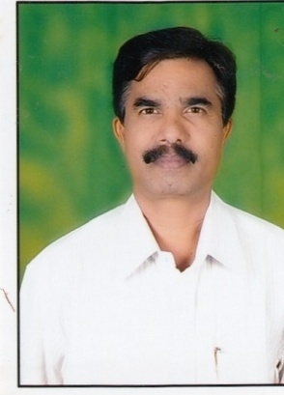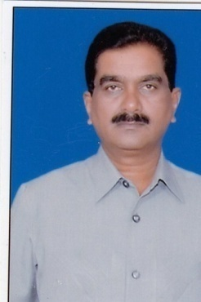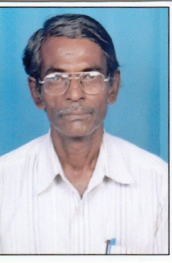
Dr.Thimma Reddy Dr.Revanasiddappa Prof.VB.Veerappa

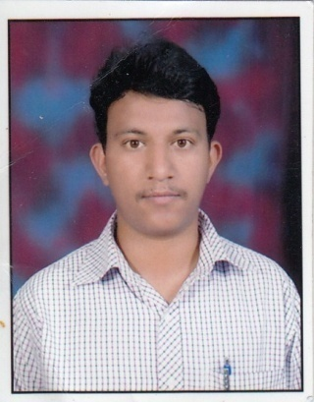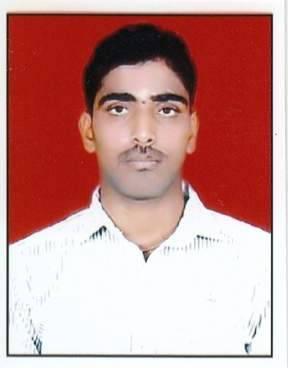
Prof.Sunil Prof.Mubina Prof.Anjaneya

